|  |
| --- |
| In recent times, Africa has also witnessed considerable improvement in its growth  performance.  For example, since the beginning of this Century, sub-Saharan Africa (SSA) has been registering positive growth rates in per capita gdp terms.  However, SSA as a region, registered the lowest annual growth rate of 4.8 in 2004. **This improved performance has been credited to the increases in prices of primary commodities, especially oil, metals and other minerals as well as agricultural commodities**.  As a result, **the oil and gas producers** including **Chad and Equatorial Guinea** registered over 10% growth rate while **Nigeria**, despite the problems in the oil producing areas, still registered 6% growth rate in 2004.  On the other hand, countries that are unable to benefit from the on-going commodity boom such as Central African Republic and Cote d’Ivoire and Eritrea, Niger and Zimbabwe registered growth rates  of less than 2 per cent in the same year. |

|  |
| --- |
| emergence of China on the world stage for African development prospects  **China Africa Policy 2006 (China-African trade relations)**  **The China-Africa**  **Policy aims at carrying forward the long tradition of China-African friendship involving**  **enhancing solidarity and cooperation with African countries. For this purpose, China pledges**  **to establish and develop new type of strategic partnership with Africa featuring political**  **equality, mutual trust, economic win-win cooperation and cultural exchange.**  **In economic field China intends to contribute to enhancing all round cooperation between**  **China and Africa primarily through trade, investment and aid which encompasses debt**  **forgiveness, concessional loan and grants**  **China is currently Africa’s third largest commercial partner after the US and 4**  **France. Furthermore, it is the second largest exporter to Africa after France and is ahead of**  **Britain in both categories**  **Oil exporters such as Algeria, Angola, and Sudan had huge trade surpluses with China,**  **China also**  **approved 16 African countries, including Ethiopia, Kenya, Uganda, and Zimbabwe, as**  **destinations for Chinese tourists** |

|  |
| --- |
| The structure of trade,  Sub-Saharan Africa (SSA) is a major producer of many of the world’s most important **minerals and metals**, including platinum-group metals (PGMs),  gold, diamonds, uranium, manganese, chromium, nickel, bauxite (aluminium raw material) and cobalt – not to mention petroleum and gas.  There are **substantial mining industries** in numerous African countries. Democratic Republic of Congo (DRC), Ghana, Namibia, Nigeria, South Africa, Tanzania and Zimbabwe are the largest mineral and metal producers in  SSA, and there are many smaller-scale producers (e.g., Botswana, Mozambique, Namibia and  Sierra Leone) (Lyakurwa, 2006) |

|  |
| --- |
| **Exports from African countries to China**   * Africa is primarily as source of crude materials and also a market for Chinese finished goods. For example, * Export from Africa have been predominantly of extractive industries products – minerals, petroleum, metals and timber – * while China has been exporting finished goods ranging from machinery and equipment to vehicles, textiles, clothing and consumer electronics. In essence, * Sudan is a major oil supplier to China, currently accounting for 7.7% of Chinese total oil imports. * Also, China has become the third major purchaser of oil from Gabon, after the United States and France, and trade relations between the two countries are expanding. For example, over 60% of Gabon’s timber is exported to Asia, mainly to China. |

|  |
| --- |
| Trend observed In Africa over the years ,     * While the shares of crude materials and manufacturing sectors have declined, that of services increased significantly. * The indication is that the growing services sector in Africa is largely in support of its export of crude materials and imports of finished goods and services. * It should be mentioned, however, that South Africa is probably the only SSA country that   shows signs of transformations similar to those of China between 1990 and 2004 (see Table  2).  **What is generally true, therefore, is that African countries are essentially exporters of**  **crude materials be it mineral or agricultural products (because that is what they specialize in)**  **and importers of transformed goods and services which is what all of its trading partners**  **specialize in.** |

|  |
| --- |
| As a result, most African countries will continue to have highly unequal  income distribution and any growth generated by export expansion is likely to have little  impact on the poor (DFID, 2005). |

|  |
| --- |
| A recent survey found that nine out of 11 countries in the world at “extreme risk” of having a food crisis are African.  But even the sceptics accept that the latest outlook for Africa is good.  The IMF says the continent’s GDP will grow by 5% this year, down from a predicted 5.4% but still much faster than almost anywhere else. In 2013 growth may nudge up to 5.7%.  Further economic problems in the rich world could hit South Africa, but countries to its north are still likely to do well.  Wolfgang Fengler, one of the two World Bank economists, has identified four causes of Africa’s economic rise:  First, the continent has the right kind of population growth: most Africans live increasingly longer while having fewer children, rather than the other way round. The UN says that Nigeria may overtake the United States by 2055 as the third-most-populous country after India and China, yet simultaneously reduce its birth rate.  Second, rapid urbanization is creating efficiency gains and luring investors to capital cities that have begun to thrive and where growing population density cuts transport times and fosters small-scale industrialization.  Third, technology is having a bigger effect on Africa than anywhere else, because it started from such a low base. In the past decade the use of telephones went from 0.7% of the population to 70% with the advent of mobile phones; Africa is a global pioneer in banking on mobile devices, not least since most people have no access to conventional banking.  Fourth, governance and economic management by officials have got better, again from very modest beginnings. The growing popularity of African sovereign debt is a good indicator.  “If current trends continue, most of Africa will be middle-income by 2025,” says Mr Fengler. But he warns that things will get harder. A lot of recent growth has been a matter of catching up, as well-known Western and Asian ideas and practices take root. Some say that the easiest ways to make money have already been exploited. Now Africa needs to build its still creaky infrastructure and diversify its companies if it is to keep up its fast growth. For that, it desperately needs two things: more capital and skilled workers.  Both are available in abundance in the West, where interest rates are low and job prospects grim. Hence the proliferation of African investment conferences in London and New York. There is much talk of where in Africa factories can be built and bonds bought. But equally high on the agenda is hunting talent from all parts of the world, Africa included. Managers search lunch tables for staff to poach and for investment professionals with experience in other emerging markets that could be useful in Africa.  According to one executive from a big Wall Street firm, salaries for Africa positions have gone up by 30% in the past year. “The continent is taking off but it’s still a tricky place to make money,” he says. “Political risks are high and contracts hard to enforce. Success often depends more on the quality of your people than on the attractiveness of the local market.”  Leading business schools in the West are getting in on the game. The London Business School held an “Africa Day” in May with a title unthinkable when colonial memories were still fresh, “Africa: Taking Ownership”. INSEAD, based in France, has an Africa Club full of former management consultants and investment bankers who want to move to the continent because—says one—they sniff an “opportunity to work at senior level with relatively little experience”. For them “Africa is like India and China ten years ago.” |

|  |
| --- |
| The top five African recipients of FDI in 2011 were dominated by oil-producing countries led by Nigeria (see figure 1). Major investment continued to flow into another significant African oil producer, Angola, but divestment and repatriated profits by transnational corporations rendered net inflows negative  While African transnational corporations are growing in influence and activity, outward FDI from Africa was still limited in 2011, especially as outflows from two traditional outward investors, Egypt and Libya, were significantly reduced.  The region’s FDI prospects for 2012 are promising, as strong economic growth, ongoing economic reforms and high commodity prices have improved investor perceptions of the continent, the report says. One such indication is that in sub-Saharan Africa, excluding South Africa, net sales related to mergers and acquisitions – the purchase of African firms by foreign transnational corporations – over the first five months of 2012 more than doubled from the same period the previous year. |

**Figure 1 - Africa: top five recipients and sources of FDI inflows, 2010 and 2011**  
(Billions of dollars)

a) Inflows  
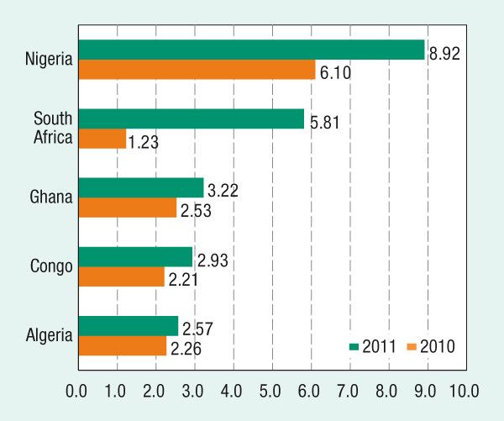

b) Outflows

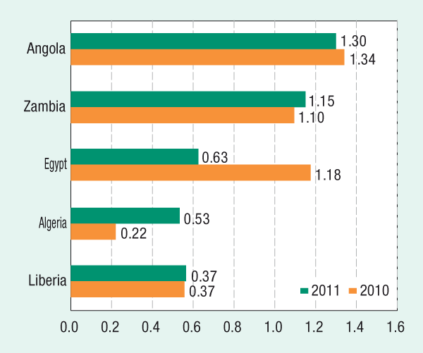

Source: UNCTAD, World Investment Report 2012

Web: [www.unctad.org/press](http://unctad.org/press)

|  |
| --- |
| Three sectors activity emerging in SubSaharan Africa, which deserve dwelling upon.  They are:  the telecommunication,  financial, and  transport sectors.  These sectors also permit measuring the intensity of foreign investments and the relative degree of good governance. The latter is often a sign of trust and convergence of foreign direct investments, and even the official recognition of the regime in power.  The telecommunication sector  Sub-Saharan Africa has witnessed in-depth reforms in the telecommunications sector, a branch of activity characterized for a long time by its technological stability and bilateral agreements between public monopolies. In |